Lesson Objective: Students will be able to distinguish the aural difference between the vowel sounds /æ/ and /ɛ/ and will be able to produce the difference orally when paying attention to form in the activities.

- Introduction of the Topic (5 min.) – Introduce the topic for the lesson, the distinction between the vowel sounds /æ/ (like in the word bad) and /ɛ/ (like in the word bed.). This difference is problematic for many ESL students, and can lead to communication breakdown when the distinction between the two vowel sounds is not made. Explain the importance of differentiating between the vowels to the students. Give the students a brief outline of what will be covered in this lesson.
- Warm-up Video Clip (10 min.) - Show the students a short video clip that gives an example of communication breakdown related to the two vowel sounds. http://www.youtube.com/watch?v=y5czC8HBEfo
This is a clip from the TV show That 70’s Show, concerning the musician Ted Nugent. Before showing the clip, briefly explain who Ted Nugent was. In the clip, there is communication breakdown when one character gets the name Tad Nugent printed on a T-Shirt, not realizing there is a difference between Tad and Ted. After showing the clip, have a brief class discussion about what happened in the clip, why there was a misunderstanding, and what the consequences were.
III. Vowel Explanation and Practice (15 min.) – Have the students practice saying all of the front vowels, from high to low. Use this chart which lists the vowels and gives an example word for each. Put the chart on the board or overhead projector so the students can see it as well.
Vowel | Example Word
i | meat
ɪ | mitt
e | mate
ɛ | met
æ | mat
Say each vowel, have the class repeat the vowel, then say the accompanying word, and have the students repeat the word. Repeat the process a few times.
After this practice, give an explanation of how to produce the two distinct vowels. Go to the University of Iowa’s Phonetics: The Sounds of Spoken English webpage (http://www.uiowa.edu/~acadtech/phonetics/#) and bring up the diagram of the front vowels /æ/ and /ɛ/. Show the diagrams of the two sounds, read the explanation of where and how to produce the sounds, and play the recordings illustrating example words. Also mention that the /æ/ sound is often longer than the /ɛ/ sound. Have the students practice producing the sounds and practice words after the diagrams and recordings have been shown.
IV. Minimal Pairs with Pictures (20 min.) – Put the students in pairs. Each pair is given five minimal pairs and the pictures that match those words. For example, there are the words bag and beg, and a picture of a bag and a picture of a dog begging. One person reads a word from the list, and the other person should pass over the matching picture. In order for the student to produce the matching picture, the reader must pronounce the word correctly, and the partner must be able to hear the correct pronunciation. When all of the words have been used, the students switch roles, so that each student has the opportunity to read the words and choose the pictures.


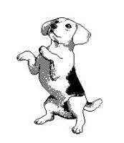
Bag Beg

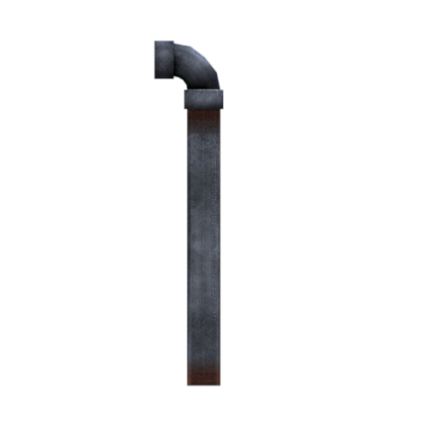
Lad Lead


Bad Bed
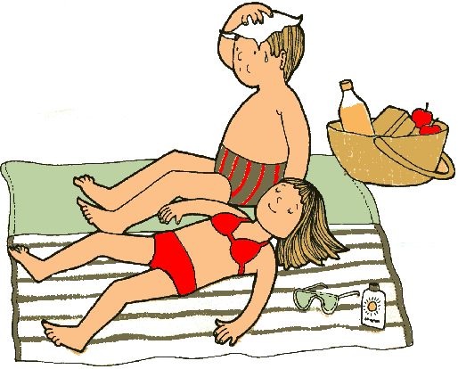

Tan Ten


Land Lend

After the activity, ask students what parts of the activity were difficult and why. Was it more difficult to produce the sounds correctly, or to hear the difference? Were some words more difficult than others?
- Minimal Pairs in Sentences (15 min.) – This activity is similar to the previous one, but moves up to the sentence level. The students remain in their pairs and receive sentences that have an option of two words. The student who reads the sentence chooses which word to read, and the student listening must determine which word has been said. After all the sentences have been read, the students switch roles.
Is that your ham/hem? Did you lose your pan/pen?
Where is the fan/fen? I lost the bat/bet.
Have you seen the man/men? Did you sand/send the chair yet?
That was quite a mass/mess!
After the students have completed the activity, regroup and discuss what was difficult, why it was difficult, etc.
- Conclusion and Assessment (10 min.) – During the activities, the instructor should go around the room and assist students/assess their progress. After these activities have been completed, provide a handout with sentences containing many uses of the two vowel sounds. Ask each student to read one of the sentences aloud to the class, so you can assess the progress the class has made. This is only a casual assessment, and the students will receive verbal feedback but no grade. Wrap-up the lesson and again emphasize the importance of distinguishing between /æ/ and /ɛ/. You should also encourage the students to pay attention to these forms in every-day life—not just during the lesson.
- The fat cat sat on the mat.
- Matt grabs the last rack of lamb.
- Jack is neither mad nor glad, happy nor sad.
- Ashley and Zachary ran past the alley.
- Jed bet the vet ten kegs.
- Ned lets the red wrens peck.
- Ed said his neck and head smell like bread.
- Lester fed the leopard twenty hens.
- The fat men hand Jen ten black pens.
- Peg and Ken dance faster than the men in west France.
- Jasmine’s pet rat heads left after the last bed.
- Lend Andrew the pegs from last Saturday.

